Enrolment No: _______________________________________________________

Name of Student: _____________________________________________________

Department/ School: ___________________________________________________

**END TERM EXAMINATION EVEN SEMESTER 2021-22**

|  |  |  |  |
| --- | --- | --- | --- |
| **COURSE CODE** | **CSET105** | **MAX. DURATION** | **2 HRS** |
| **COURSE TITLE** | **Digital Design** | | |
| **COURSE CREDIT** | **3-0-2** | **TOTAL MARKS** | **35** |

**GENERAL INSTRUCTIONS: -**

1. Do not write anything on the question paper except **name, enrolment number** and **department/school.**
2. Carrying mobile phone, smart watch and any other non-permissible materials in the examination hall is an act of **UFM.**

**COURSE INSTRUCTIONS:**

1. **Answers should be to the point.**
2. **If needed, make the Neat and clean Diagrams.**
3. **Question 1 has the 3 Marks and other all questions have 4 marks.**

**Max Marks: 35 Marks**

**Q1. (a).** Construct truth table of the given logic diagram. Where (D- Input, C- Clock, Q and Q’- Outputs). **[3]**

**(b).** Explain in one sentence.

1. Drawback with S-R Flipflop.

2. Drawback with J-K Flipflop.

**Q2.** The Following serial data are applied to FF shown in Figure. Determine the resulting serial data that appears at Q output. There is one clock pulse for each bit time. Assume initially Q=0. **[4]**

|  |  |  |  |  |  |  |
| --- | --- | --- | --- | --- | --- | --- |
| CLOCK | J1 | J2 | K1 | K2 | Q |  |
| 1st | 1 | 1 | 1 | 1 | ? 0 | ? 1 |
| 2nd | 0 | 1 | 0 | 1 | ? 0 | ? 1 |
| 3rd | 1 | 0 | 0 | 0 | ? 0 | ? 1 |

**Q3.** A new Flip Flop (XY) is designed with the following Truth table. The previous state of XY Flip Flop is and the Next State Denoted by .For the New Flip Flop create the Characteristic Table and Excitation Table also Find the Characteristic Equation for Given Flip Flop. **[4]**

**Truth Table of XY Flip Flop**

|  |  |  |  |
| --- | --- | --- | --- |
|  | Input | Input | Output |
| **Clock** | **X** | **Y** |  |
| 0 | Don’t care | Don’t care |  |
| 1 | 0 | 0 | 1 |
| 1 | 0 | 1 |  |
| 1 | 1 | 0 |  |
| 1 | 1 | 1 | 0 |

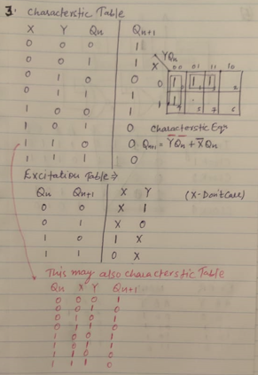

**Q4.** Design a 2-bit Synchronous Down Counter with detailed diagram. **[4]**

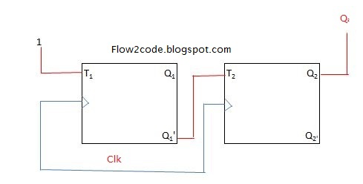

**Q5.**  In SIPO Register (Given in the Diagram), Find the output (A, B, C, D) after 1st clock, 2nd clock, 3rd clock, and 4th clock. **[4]**

|  |  |  |  |  |
| --- | --- | --- | --- | --- |
| Clock | A | B | C | D |
| Initial (0) | 1 | 1 | 1 | 0 |
| 1st | 0 | 1 | 1 | 1 |
| 2nd | 1 | 0 | 1 | 1 |
| 3rd | 0 | 1 | 0 | 1 |
| 4th | 1 | 0 | 1 | 0 |

**Q6.** Design an asynchronous counter using T flipflop for the following sequence. **[4]**

**110 state will be converted to 000**

**(Instead of J K FF use T flip flop and Make Input Logic 1)**

**Q7.** Convert the S R Flip Flop to T Flip Flop with suitable tables and Logic expression and Logic Diagram. **[4]**

**Q8.** Design a counter which has no. of states double of no. of Flip Flop used in that counter circuit with the suitable diagram. [4]

**Johnson Counter**

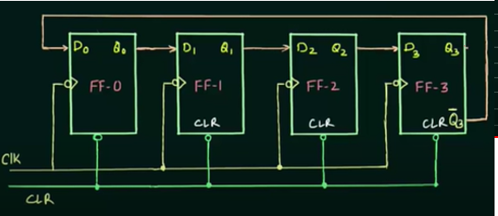

**Q9.** Draw the Output wave form (Q) of the given JK Flip Flop for given Input waveform. (Assume previous State =1) **[4]**

😊😊😊ALL THE BEST😊😊😊